# A description of the objectives/concepts explored in the chapter:

The Goal of this lab is to learn the different type of variables that the microcontroller can understand, as well as how to manipulate them. We also have to see how different variables affect performance or processing power for performing the same task. In this lab, we also learned how to use interrupts in order to trigger certain actions. In the 3rd part of this lab, we used the rtcc interrupt to generate a one second delay for displaying (M number modulo 1021 + 1) in the LEDs.

# A discussion of your implementation of the demonstration task and description of your results.:

In this lab, we have 3 parts:

1. Part1: Performing division for different type of number variables (Integers, floats, long integers…). The goal was to just use the same numbers and program as the one provided in the book, in order to see the difference on clock cycle usage for different numbers by looking on the value of TMR1. We declared different variable for each type of number and before the performance of each division, we reset the timer and look at the value of timer 1 after the computation is performed. We use the debugging controls reset and step over to see the value in the watch window giving us the number of cycles it took for that computation to be performed.

This is a snapshot of the different values given by multiplication versus division:

|  |  |  |  |  |  |  |  |  |  |
| --- | --- | --- | --- | --- | --- | --- | --- | --- | --- |
| Multiplication | | | | | Divison | | | | |
| Multiplication | Cycle Count | Performance relative to | | | Division Test | Cycle Count | Performance relative to | | |
| int | long | float | int | long | float |
| Integer | 4 | 1 | 0 | 0 | Integer | 23 | 1 | 0 | 0 |
| Long integer | 13 | 3 | 1 | 0 | Long integer | 553 | 24 | 1 | 1 |
| Long Long integer | 123 | 31 | 9 | 1 | Long Long integer | 9152 | 398 | 16 | 19 |
| Single precision f.p | 158 | 40 | 12 | 1 | Single precision f.p | 480 | 21 | 1 | 1 |
| Double precision f/p | 436 | 109 | 34 | 3 | Double precision f/p | 1353 | 59 | 2 | 3 |

Using the watch window we can see the value of TMR1, this is an example:



1. Part2: The goal of part 2 was to use the RTCC timer interrupt and generate a 1 second delay to make the Value of our M number modulo 1021 flash on the LED’s.

We use the Alarm functions to make a half second alarm, then we use the RTC interrupt to toggle the numbers displayed in the LCD. I used the same digits function I used in the previous lab and a macro for the calculation to display that value. For the RTC interrupt, we first need to initialize the RTC and the secondary oscillator in order to use the RTC. I defined some functions to make it easy to turn RTC on and OFF as well as initialize use the secondary oscillator in my config file:

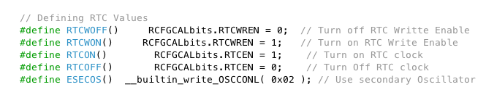

This makes it easy to set my config bits without any problem, for some reason the RTC write enable was only working by using the __builtin_write command.

After this I created a function to initialize RTC and set the date and time into the RTC register. When doing that RTC need to be turned off and enable witting into the register then after it’s all done it needs to be turned back ON.

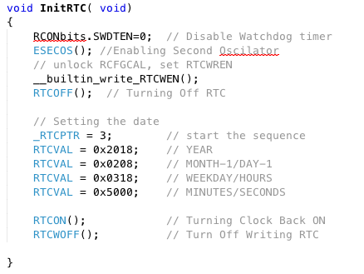

Once that’s done, in the main function we just need to deactivate the alarm and set it for every half second and using that we clear the interrupt flag and enable the interrupt every half a second.

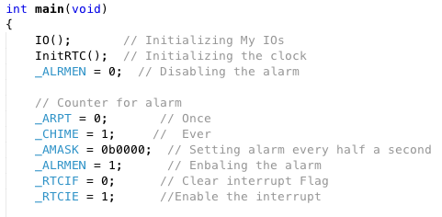

Once the interrupt is enabled the program jumps to our interrupt RC function which has a value, I named RTC_I that gets toggled every half a second. This value will direct whether we want to display the value of our result in the LED’s or turn them off.

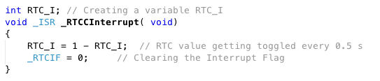

After this we go back to the main function, which show the result of our calculation in the LED’s for 0.5 second (RTC_I = 1) and turn off the LED’s (RTC_I = 0).

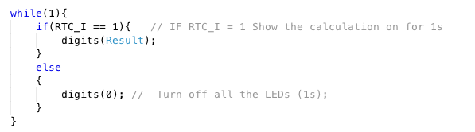

This is what helps us display the value of our (M number modulo 1021 + 1) every second and turn it off for the other second.

1. Part3: for this part we had to manipulate the string of our name using the String.h library in order to extract from it our 6+2 or 4+2 in my case given that my last name has only 4 characters.

I created a constant character containing my name and a string of 6 letters called six_two that will contain the 6+2 extracted from my name:



Looking at the string.h file in the library, I found that the library contained functions to move arrays of a string to a certain place in another string. Here is a snapshot of that:

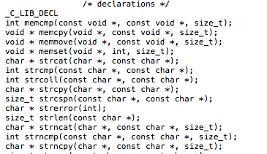

memove (str2, str(n/+p), z); will move to str2 the character(s) at position n or +p and z is the size of the characters to move.

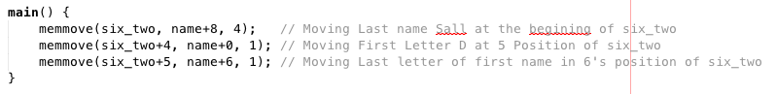

On the first line I move 4 letters starting from the 8 position of my const char (Djibril Sall) 4 letters. This will move Sall to six_two.

Then I move the letter D from my name to the 5 position on six_two and finally move the L on my name to the 6’s position on six_two.

The result gives me this on the watch window:





# The program code for programs written to achieve the demonstration tasks:

I have 2 files a config.h and my main.c file for each program. The config file is the same for all the different parts.

In the config.h I set my bits as the previous labs and add the digits function that heps display any value in the LED’s.

1. Config.h:

* First defining IO’s and different commands as well as config bits.

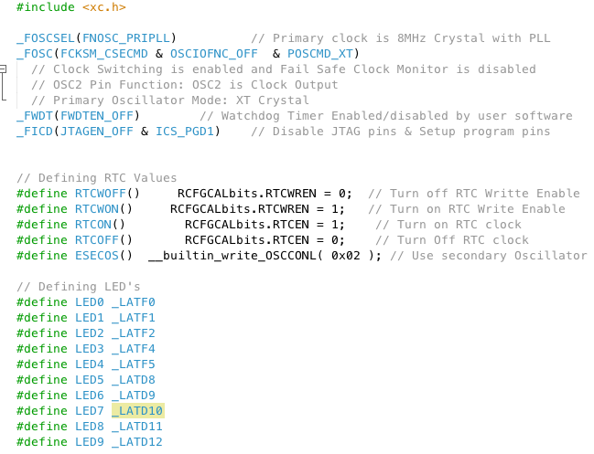

* Initializing the RTC.

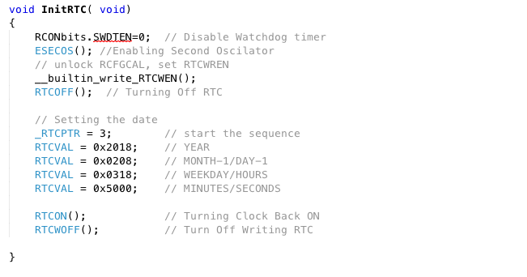

* Setting my IO’s:

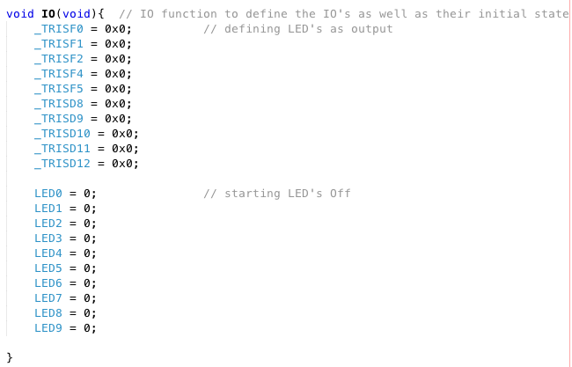

* Digits function to include show values in the LEDs:

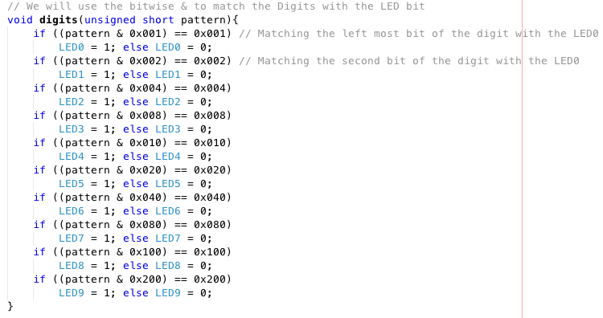

After this I had the main file for each part.

1. Main Files:

* Part1 main.c:

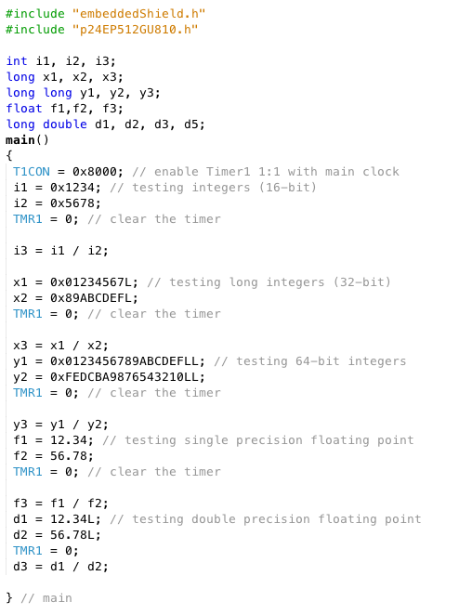

These are the watch windows:











* Part2 main.c:

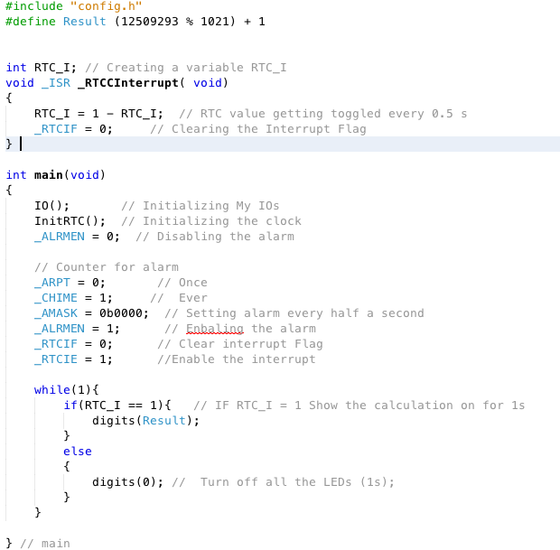

This is a link to my video:

<https://photos.app.goo.gl/wJ5Gw9aVkhG58Fka2>

* Part 3 main.c:

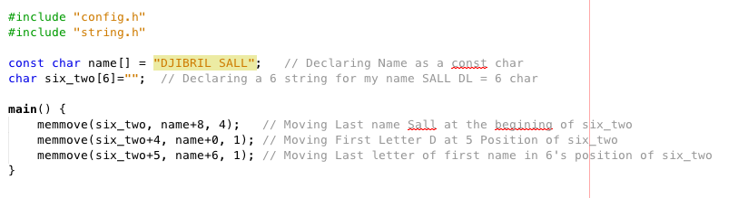

watch windows:



# A brief discussion of what you learned from the chapter and demonstration tasks:

This lab helped us learned the different type of numbers that we can use when programming the pic24 as well as how to manipulate them. It also help us see the difference in performance related to the type of numbers used. For example we can see that float numbers requires more clock cycles as much as 40 times for a multiplication and 20 times for a division compared to an integer. Therefor this tells us how important it is to use different numbers with care depending on our application and calculation specially when some operations are time sensitive. If we were to use an application that requires updates at some small amount of clock cycles, it could lead to bigger problems when a certain action is not performed fully. It also reminded me of the incident that happened in the 90’s where a patriot missile do to some float calculation misses was no longer intercepting missiles after a certain number of calculations. We can also see how this can be a problem if we were using it in the healthcare industry and some actions needed to be performed at a certain time and if the calculations were taking longer it could be fatal to the person. For example if a correction of dosage delivered to a certain person needed to be performed with accuracy and an increase of the limit of dosage could kill the person, it will be really important to make sure that the computation will be performed in a timely manner. Given that most of the actions we performs are really slow compared to the microcontrolers (Mhz), the only place it can be a problem is with fast moving devices.

For the RTC assignment, it gave us an insight into the RTC module and how to use certain functions like the alarm and also as an interrupt. This could be used to generate a clock in any project and the alarm can be also used to perform maintenance in our program or resetting everything at a certain time of every day or year.

As for the 6+2 it just gives us an inside of the different libraries included in mplabx ide and how even some c functions can be interpreted by the compiler and perform hardware level actions. Looking at the watch window also help us apprehend how the microcontroller save different characters in different memory spaces.